# **Software Engineering Project**

### **Data Flow Diagrams for Alumni Portal :**

DFD 0

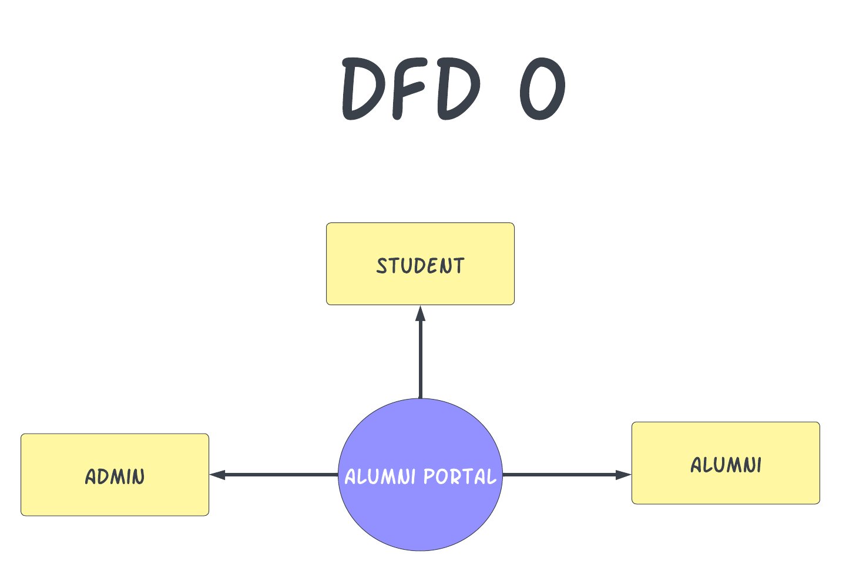

DFD 1

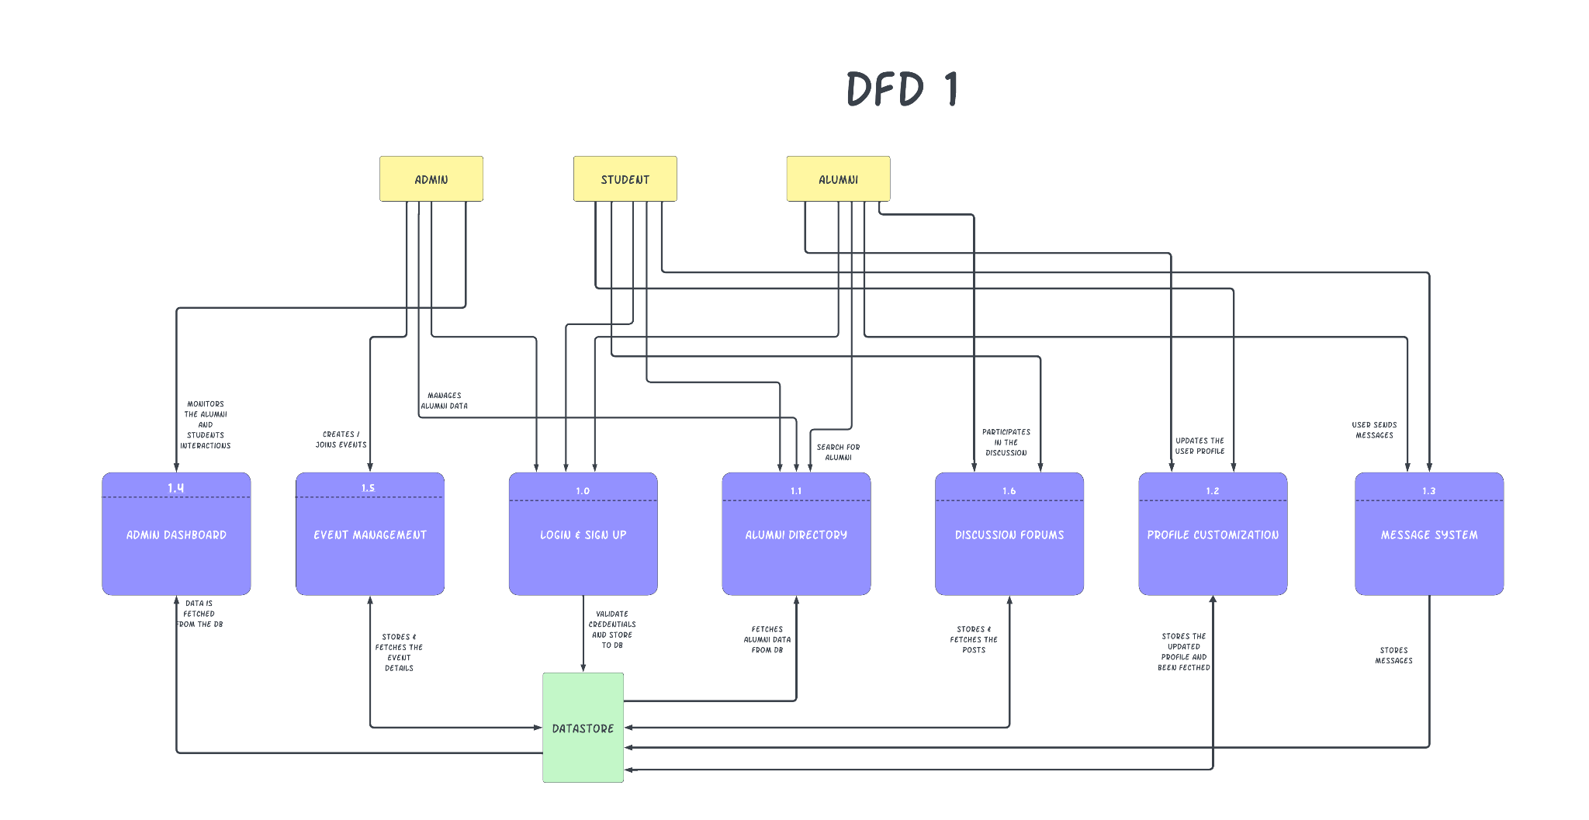

DFD 2

